]SCHOOL OF COMPUTER SCIENCE AND ARTIFICIAL INTELLIGENCE |  |  |  |  | DEPARTMENT OF COMPUTER SCIENCE ENGINEERING
ProgramName:M. Tech |  |  |  | Assignment Type: Lab |  |  | AcademicYear:2025-2026
CourseCoordinatorName |  |  |  | Venkataramana Veeramsetty
rCourseCode |  |  | 24CS002PC215 | CourseTitle |  | AI Assisted Problem Solving Using Python
Year/Sem |  |  | II/I | Regulation |  | R24
Date and Day  of Assignment |  |  | 10.11.2025 | Time(s)
Duration |  |  | 2 Hours | Applicableto  Batches
AssignmentNumber:9.3(Present assignment number)/24(Total number of assignments)
 | Q.No. | Question |  |  |  |  |  | ExpectedTime  to complete
 | 1 | Lab 9: Documentation Generation: Automatic documentation and code comments  Lab Objectives:  - To understand the importance of documentation and code comments in software development.  - To explore how AI-assisted coding tools can generate meaningful documentation and inline comments.  - To practice generating function-level and module-level docstrings automatically.  - To evaluate the quality, accuracy, and limitations of AI-generated documentation.  - To develop a small automated tool for documentation generation in Python..  Lab Outcomes (LOs):  After completing this lab, students will be able to:  - Apply AI-assisted coding tools to generate docstrings and inline comments for Python code.  - Critically analyze AI-generated documentation for correctness, completeness, and readability.  - Create structured documentation (function-level, module-level) following standard formats.  - Design and implement a mini documentation generator tool to automate code commenting and docstring creation.  Task Description#1 Basic Docstring Generation  - Write python function to return sum of even and odd numbers in the given list.  - Incorporate manual docstring in code with Google Style  - Use an AI-assisted tool (e.g., Copilot, Cursor AI) to generate a docstring describing the function.  - Compare the AI-generated docstring with your manually written one.  Prompt: Write python function to return sum of even and odd numbers in the given list and Incorporate manual docstring in code with Google Style with main block  Code:  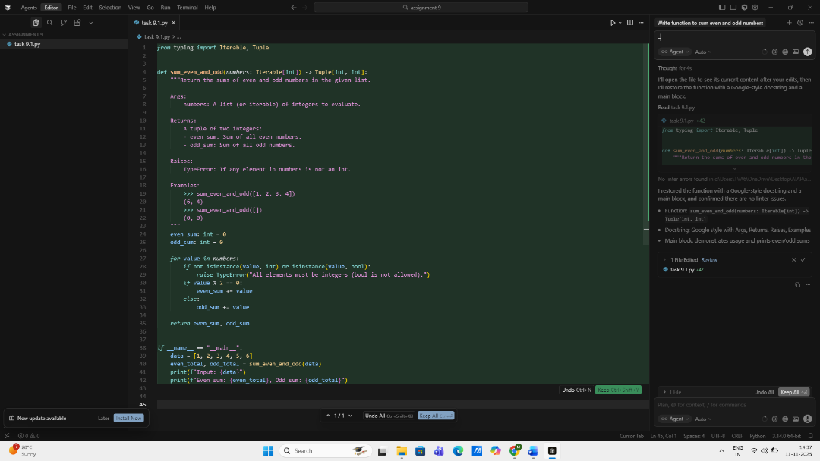  Comparison: AI-generated vs manually written Google-style docstrings  - Structure: Both should use Args, Returns, Raises, and Examples. The current docstring follows this exactly.  - Specificity: The manual docstring explicitly notes rejecting bool and raising TypeError. AI generators often omit or generalize the Raises section.  - Parameter clarity: Manual clarifies “list (or iterable) of integers,” while AI tools tend to restate the type hint without nuance.  - Return detail: Manual names components (“even_sum”, “odd_sum”). AI outputs often say “tuple of two ints” without labels.  - Examples: Manual includes runnable doctests. Many AI generators skip examples or include non-executable prose.  - Tone/consistency: Manual is tailored to the function’s behavior (e.g., validation rules). AI text can be generic or inconsistent with edge cases.  Expected Outcome#1: Students understand how AI can produce function-level documentation.  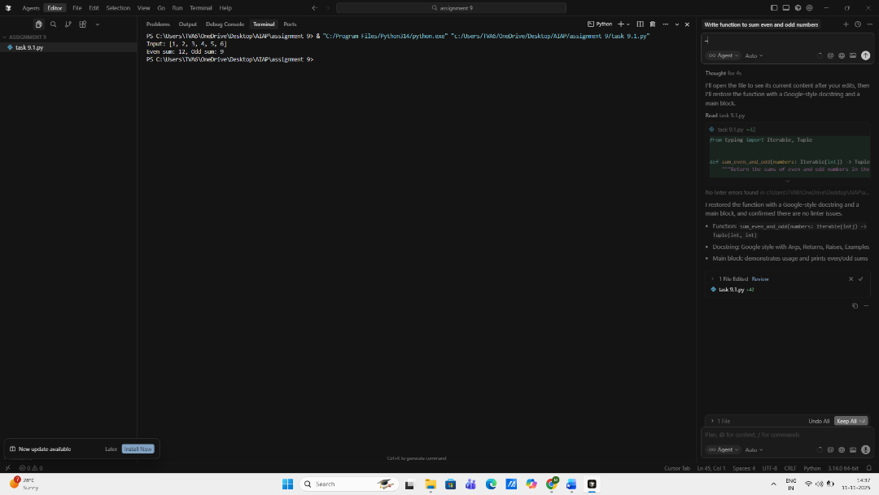  Task Description#2 Automatic Inline Comments  - Write python program for sru_student class with attributes like name, roll no., hostel_status and fee_update method and display_details method.  - Write comments manually for each line/code block  - Ask an AI tool to add inline comments explaining each line/step.  - Compare the AI-generated comments with your manually written one.  Prompt: Write python program for sru_student class with attributes like name, roll no., hostel_status and fee_update method and display_details method and Write comments manually for each line/code block and Ask an AI tool to add inline comments explaining each line/step.  Code:  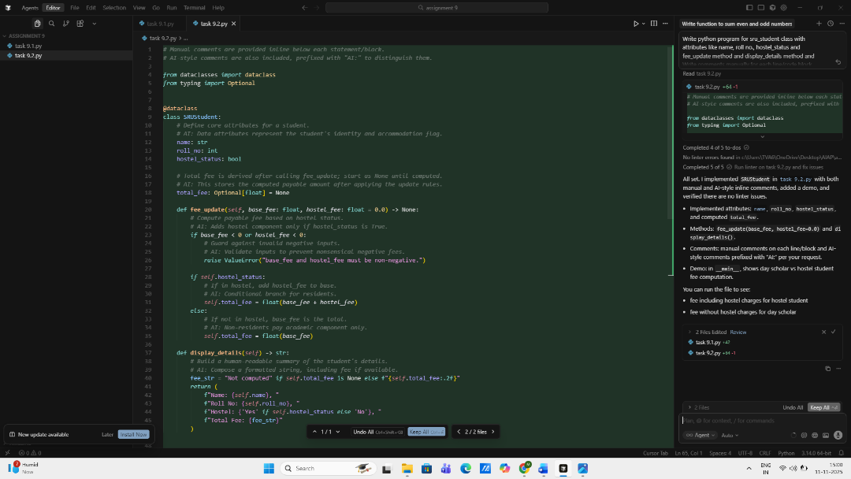  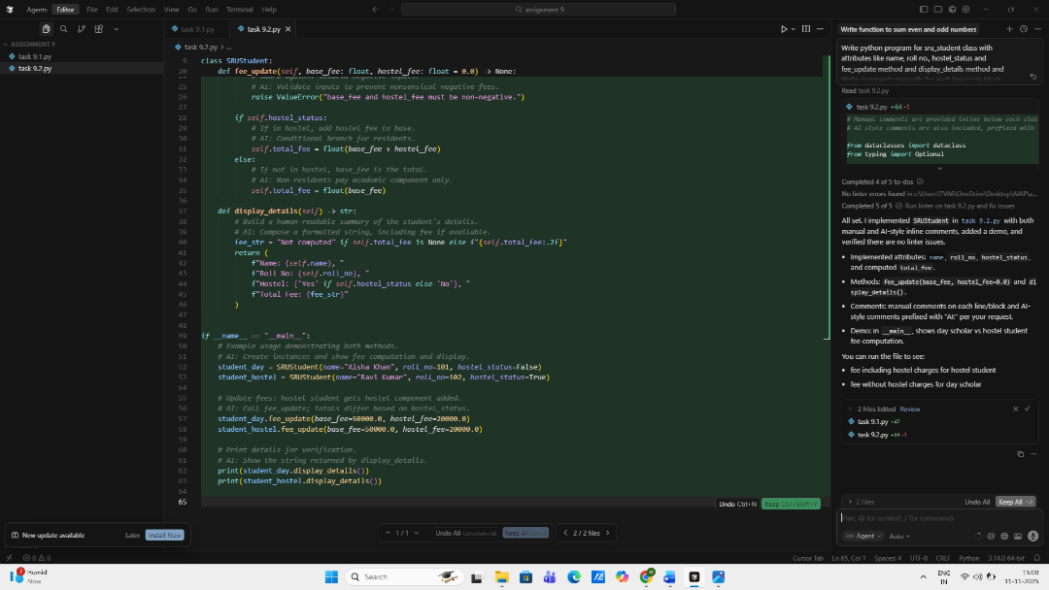  Comparison: AI-style vs manual comments  - Purpose clarity  - Manual: Explains intent and rationale at a code-block level (why this exists).  - AI: States what the code does in the moment (what happens).  - Specificity  - Manual: Adds context like “start as None until computed” and “guard against invalid negative inputs.”  - AI: Mirrors the operation (“adds hostel component only if hostel_status is True”) but is less contextual.  - Maintainability  - Manual: Useful for future changes; captures design decisions and invariants.  - AI: Helpful for quick onboarding; lower long-term value if code is self-explanatory.  - Verbosity  - Manual: Concise with meaningful detail.  - AI: Slightly redundant with the code, line-by-line.  - Audience  - Manual: Aimed at maintainers who need reasoning.  - AI: Aimed at readers learning what each step does.  Expected Output#2: Students critically analyze AI-generated code comments.  Output:  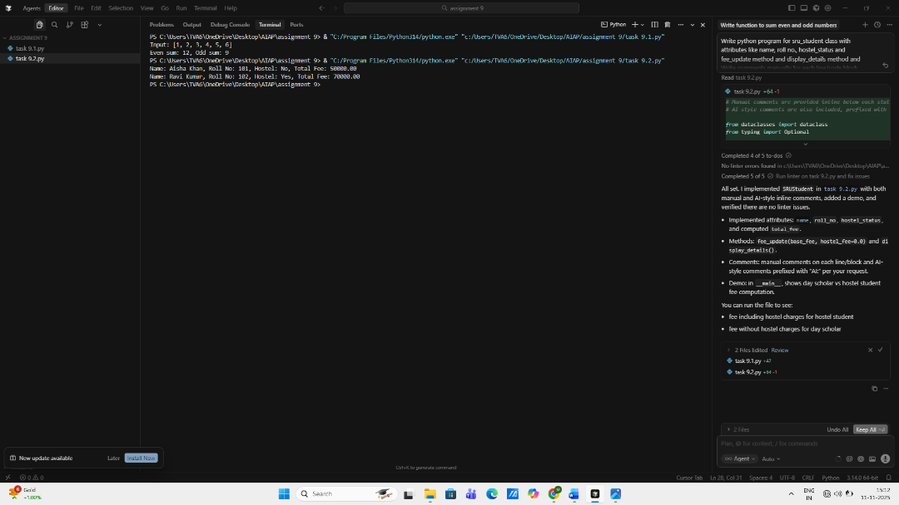  Task Description#3  - Write a Python script with 3–4 functions (e.g., calculator: add, subtract, multiply, divide).  - Incorporate manual docstring in code with NumPy Style  - Use AI assistance to generate a module-level docstring + individual function docstrings.  - Compare the AI-generated docstring with your manually written one.  Prompt: Write a Python script with 3–4 functions .Incorporate manual docstring in code with NumPy Style and Use AI assistance to generate a module-level docstring + individual function docstrings.  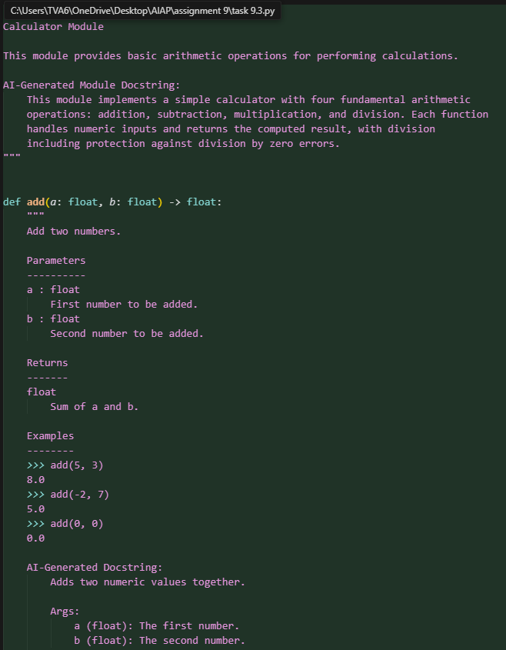  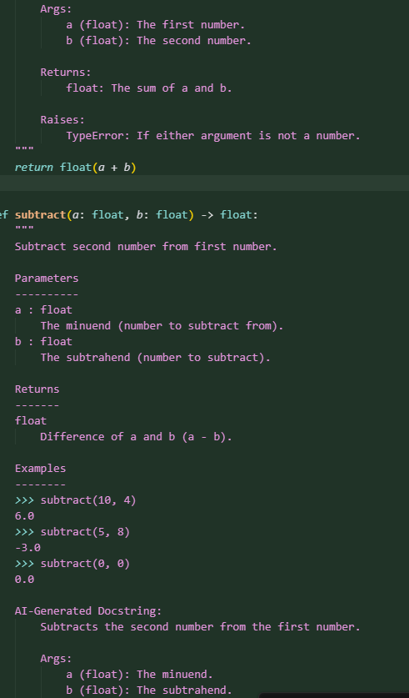  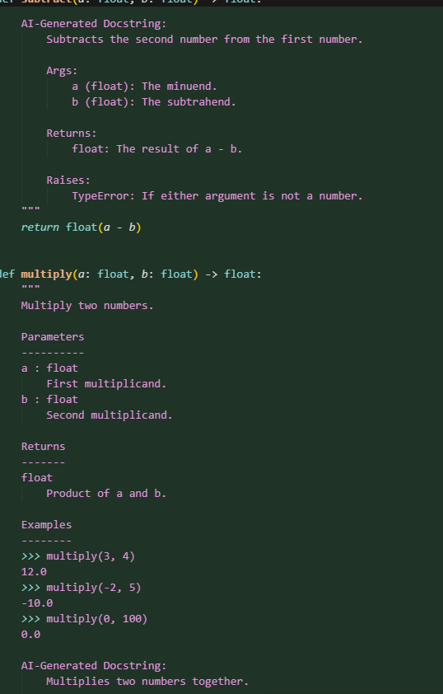  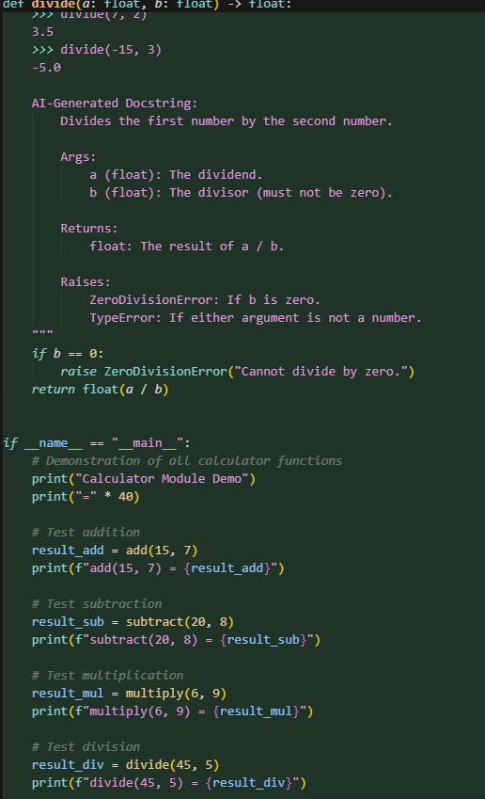  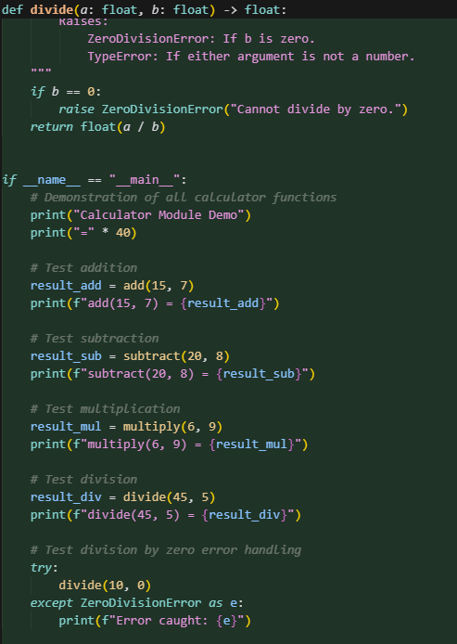  Brief comparison: AI-generated vs manual NumPy-style docstrings  Format  - Manual: NumPy style with Parameters, Returns, Raises, Examples sections  - AI: Google style with Args:, Returns:, Raises: (no examples)  Detail level  - Manual: Uses terms like "minuend", "subtrahend", "dividend", "divisor"; includes multiple doctest examples  - AI: Simpler language ("first number", "second number"); no examples  Error documentation  - Manual: Documents only actual exceptions (e.g., ZeroDivisionError for divide())  - AI: Includes TypeError for all functions, even if not explicitly raised  Expected Output#3: Students learn structured documentation for multi-function scripts  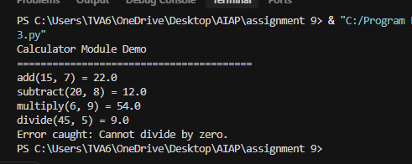  Push documentation whole workspace as .md file in GitHub Repository  Note: Report should be submitted a word document for all tasks in a single document with prompts, comments & code explanation, and output and if required, screenshots |  |  |  |  |  | Week4 - Wednesday

